HDOC DAY -16
Algorithm:
1. Start.
2.Define variables and data types
n (integer), choice (integer), digit (integer), largest (integer), smallest (integer), second_largest (integer), second_smallest (integer)
3.Get the input positive integer n and menu choice.
4.Display the menu for the required digit-based operations.
5.Use switch-case according to the user's choice.
- 5.1 Check whether digits are in increasing order from left to right.
- 5.2 Check whether digits are in decreasing order from left to right.
- 5.3 Find the largest and smallest digit.
- 5.4 Find the second largest and second smallest digit.
6. Extract digits using % 10 and / 10 and perform the required comparison.
7.Call the respective void function for the selected menu option and display the result.
8.Repeat the menu until the user selects Exit.
9. Stop.
C code :
#include <stdio.h>

void increasing()
{
int n, d, p, flag = 1;
printf("Enter number: ");
scanf("%d", &n);

p = n % 10;
n = n / 10;

while(n > 0)
{
d = n % 10;
if(d > p)
flag = 0;
p = d;
n = n / 10;
}

if(flag)
printf("Increasing order\n");
else
printf("Not increasing order\n");
}

void decreasing()
{
int n, d, p, flag = 1;
printf("Enter number: ");
scanf("%d", &n);

p = n % 10;
n = n / 10;

while(n > 0)
{
d = n % 10;
if(d < p)
flag = 0;
p = d;
n = n / 10;
}

if(flag)
printf("Decreasing order\n");
else
printf("Not decreasing order\n");
}

void largeSmall()
{
int n, d, l = 0, s = 9;
printf("Enter number: ");
scanf("%d", &n);

while(n > 0)
{
d = n % 10;

if(d > l)
l = d;
if(d < s)
s = d;

n = n / 10;
}

printf("Largest = %d\n", l);
printf("Smallest = %d\n", s);
}

void second()
{
int n, d, l = -1, sl = -1, s = 10, ss = 10;
printf("Enter number: ");
scanf("%d", &n);

while(n > 0)
{
d = n % 10;

if(d > l)
{
sl = l;
l = d;
}
else if(d > sl && d != l)
sl = d;

if(d < s)
{
ss = s;
s = d;
}
else if(d < ss && d != s)
ss = d;

n = n / 10;
}

printf("Second largest = %d\n", sl);
printf("Second smallest = %d\n", ss);
}

int main()
{
int ch;

do
{
printf("\n1. Increasing order");
printf("\n2. Decreasing order");
printf("\n3. Largest and Smallest");
printf("\n4. Second Largest and Smallest");
printf("\n5. Exit");

printf("\nEnter choice: ");
scanf("%d", &ch);

switch(ch)
{
case 1: increasing(); break;
case 2: decreasing(); break;
case 3: largeSmall(); break;
case 4: second(); break;
case 5: printf("Exit\n"); break;
default: printf("Invalid choice\n");
}

} while(ch != 5);

return 0;
}

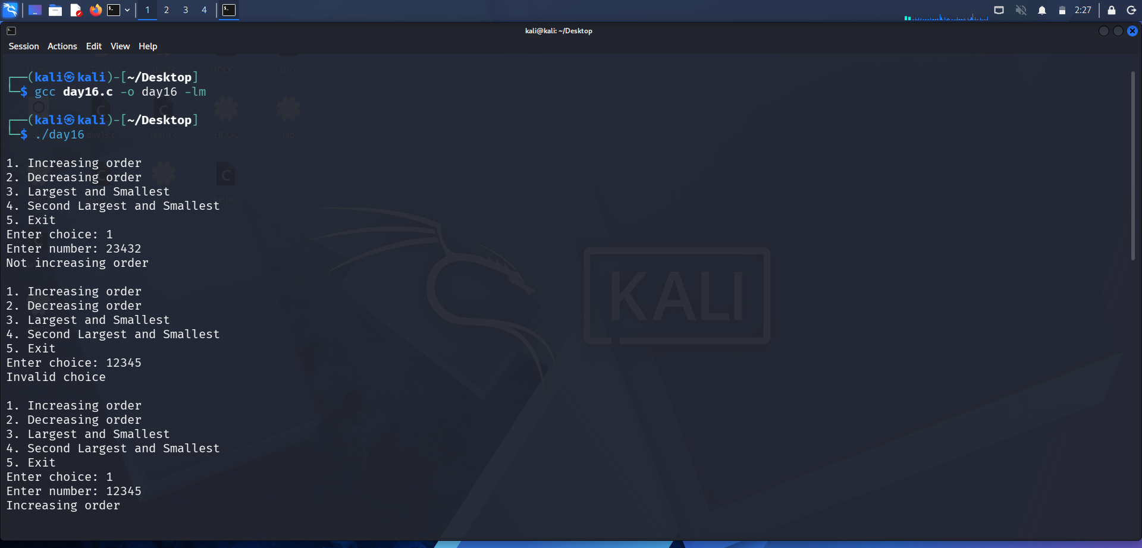

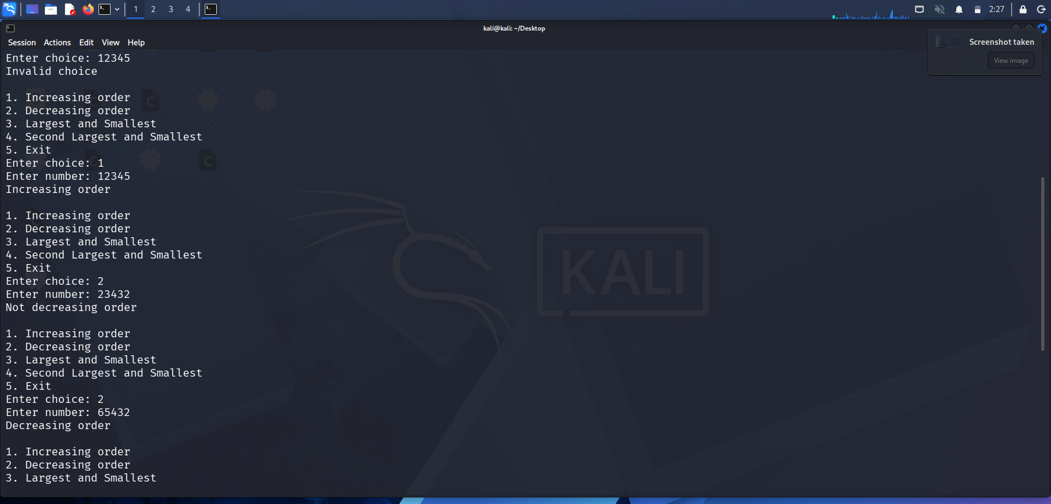
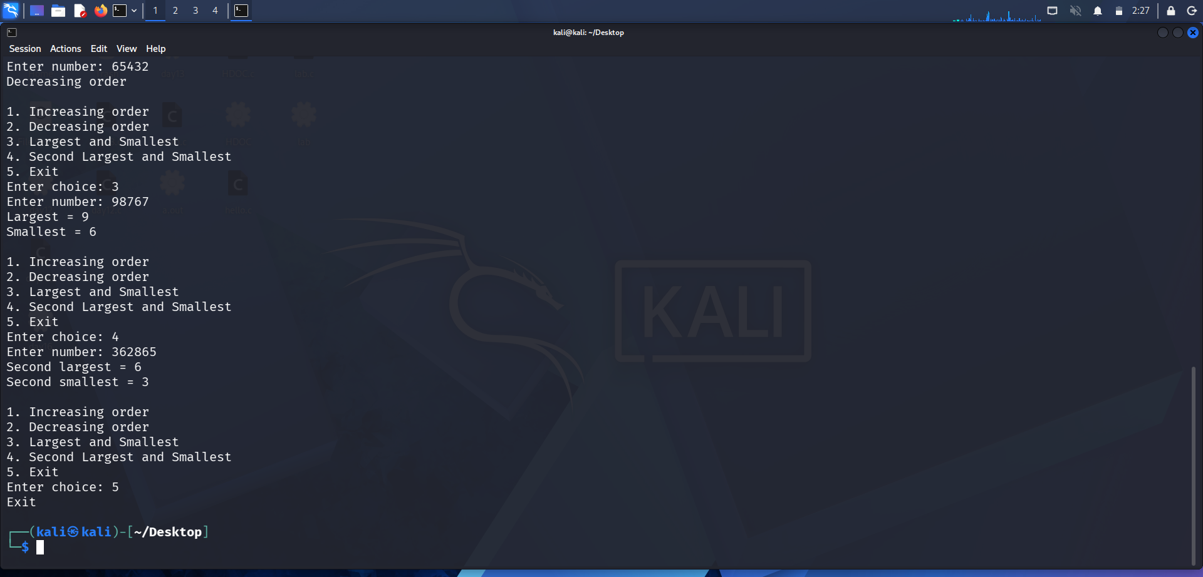
Test case | Choice | Input | Expected output | Actual output | result
1 | 1 | 23432 | Not increasing order | Not increasing order | Pass
2 | 1 | 12345 | Increasing | increasing | Pass
3 | 2 | 23432 | Not decreasing | Not decreasing | Pass
4 | 2 | 65432 | Decreasing | Decreasing | Pass
5 | 3 | 98767 | Largest =9  Smallest =6 | Largest =9  Smallest =6 | Pass
6 | 4 | 362865 | 2nd largest =6  2nd smallest=3 | 2nd largest=6  2nd smallest=3 | pass

Overall result : All pass

